Student Name: Azamat Salamatov

Professor Cleveland

COMP 3324 - 1

Week3 - Lab1

February 12, 2023,

Sniffing UDP and TCP Traffic with Wireshark

Contents

DNS Lookup 1

TCP Handshake Capturing 2

# DNS (Domain Name System) Lookup

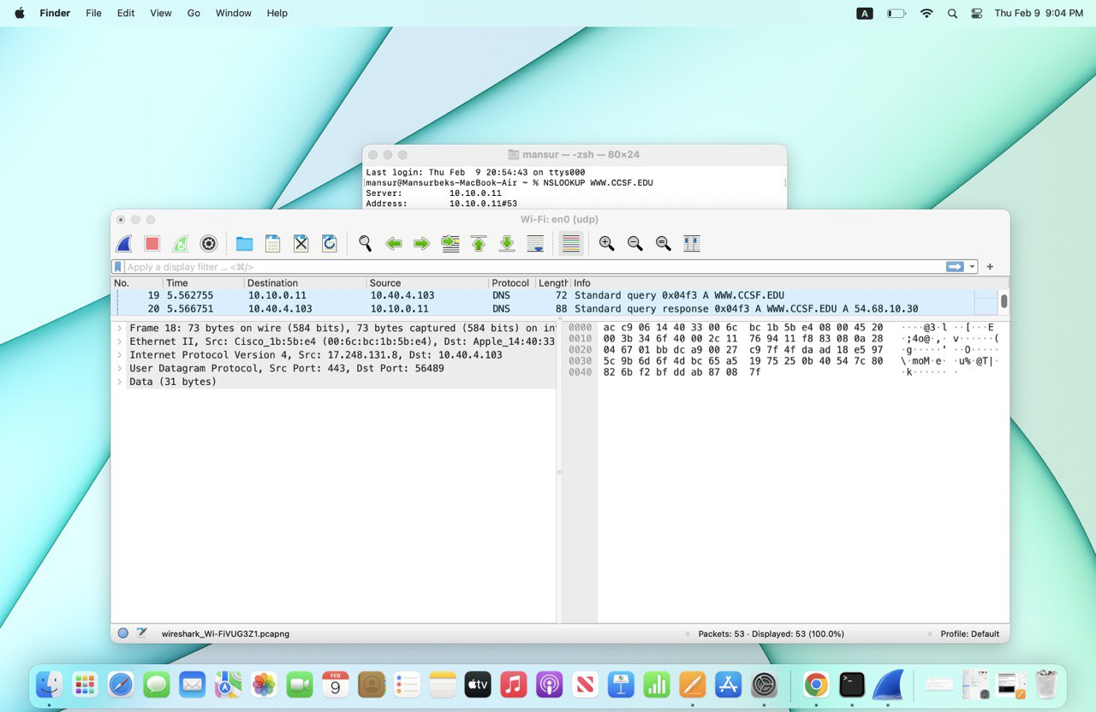



# TCP (Transmission Control Protocol) Handshake Capturing

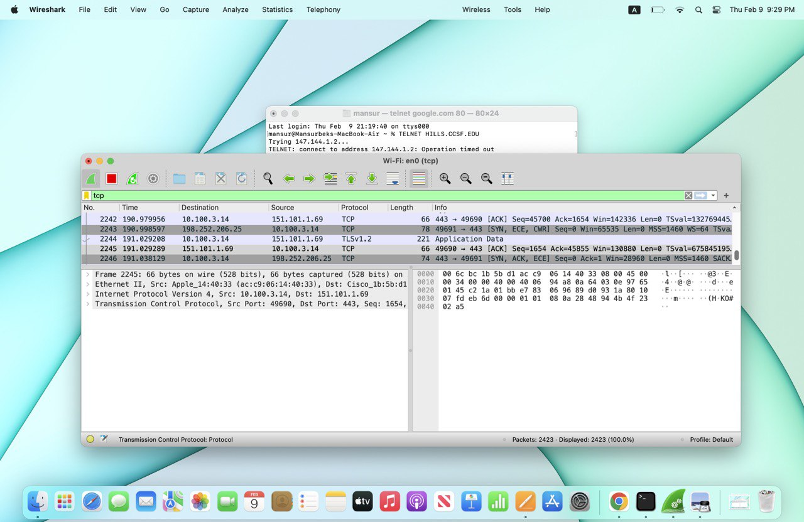



* Using “tcp” in the Filter bar was the only way, we were able to get necessary information. Using “tcp.port==23” did not work.

**One extra point I learnt after this homework is that Using the University’s WIFI blocked us from accessing “tcp”.

*** I used the laptop of my friend, Mansurbek Satarov. On my Windows Device, Wireshark did not work.